ÚDARÁS NA hOLLSCOILE / COMMITTEE PAPER TEMPLATE FOR CAPITAL PROJECTS

Project | [Project title] |  | Sponsor | [Name & Title] |  | Report Period | [Insert date] |  | RAG Status | [Insert Status]
Project | [Project title] |  | PM | [Name & Title]

Budget Report | Approved budget  (FRC minute) | Committed  to date | Spend to date | Available balance | Notes

Complete activities this period |  |  |  | Key Milestones
Task 1 Area (e.g. historic data): Description of task completed |  |  |  |  | On Track | At Risk | Off Plan | Complete
 |  |  |  | 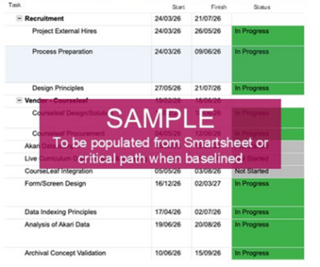
Planned activities in the next planning period

Task 1 Area (e.g. configuration): Description of task to be completed

Risks/ Issues/ Blockers | Migration | Owner
Risk # (from RAID Log):  Risk/ issue description | Migration plan: Outline of tasks | [Name & title]
Sponsor/ PM commentary (Key issues, RAG status escalation etc.)
[Insert text]

S-curve of project spend

[Insert s-curve of project spend i.e. curve showing actual and anticipated cumulative spend to completion vs budget – see illustrative example and notes below]

Sample s-curve of project spend (FOR ILLUSTRATIVE PURPOSES ONLY – PLEASE DELETE FOR COMMITTEE PAPER SUBMISSION)

The following is a illustrative sample of a s-curve of project spend i.e. curve showing actual and anticipated cumulative spend to completion vs budget (see associates notes below).
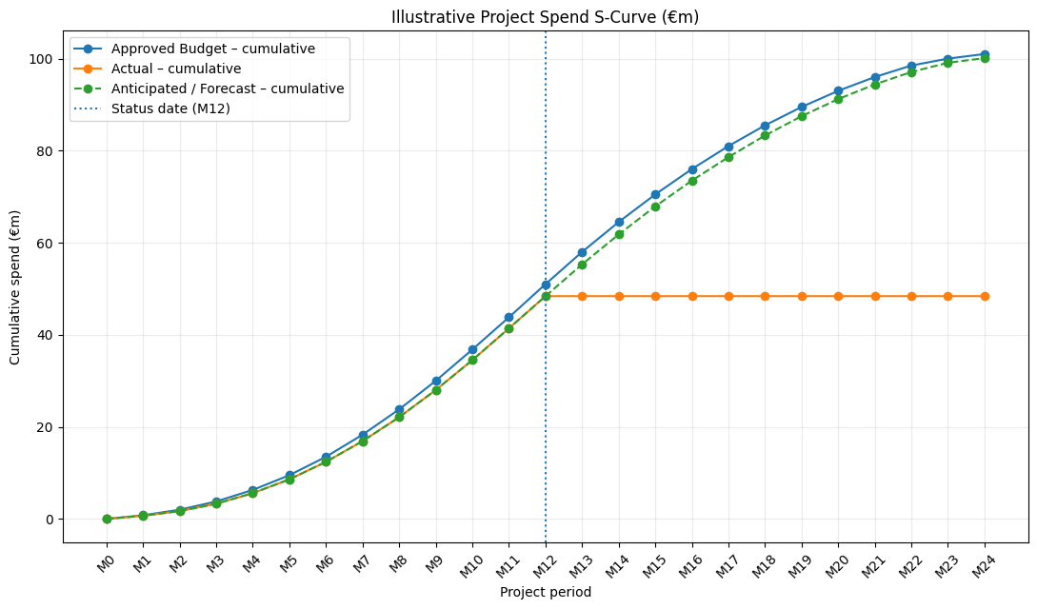

Sample s-curve of project spend (FOR INFORMATION PURPOSES ONLY – PLEASE DELETE FOR COMMITTEE PAPER SUBMISSION)

The above illustrative example assumes a €100m approved project budget, with the reporting/status date at Month 12. In this example, actual expenditure is €48.8m at the status date and the forecast final cost is approximately €99.9m (see table for underlying data).  Provide an updated cumulative project spend S-curve showing:  - Approved Budget – the cumulative expenditure profile based on the approved project budget/baseline.  - Actual Spend – cumulative actual expenditure incurred to the reporting/status date.  - Forecast Spend – anticipated cumulative expenditure from the status date through to project completion, based on the latest cost forecast.  - Clearly identify the reporting/status date on the graph.  - The forecast should extend through project completion, allowing the reader to assess the anticipated final cost against the approved budget.  - Where the forecast final cost differs from the approved budget, provide the € and % variance and briefly explain the principal drivers.  Important:  The actual line should stop at the reporting date; it should not be artificially extended. The forecast line should then continue from that point to completion. This makes the distinction between what has been spent and what is anticipated to be spent immediately clear. |  | 