


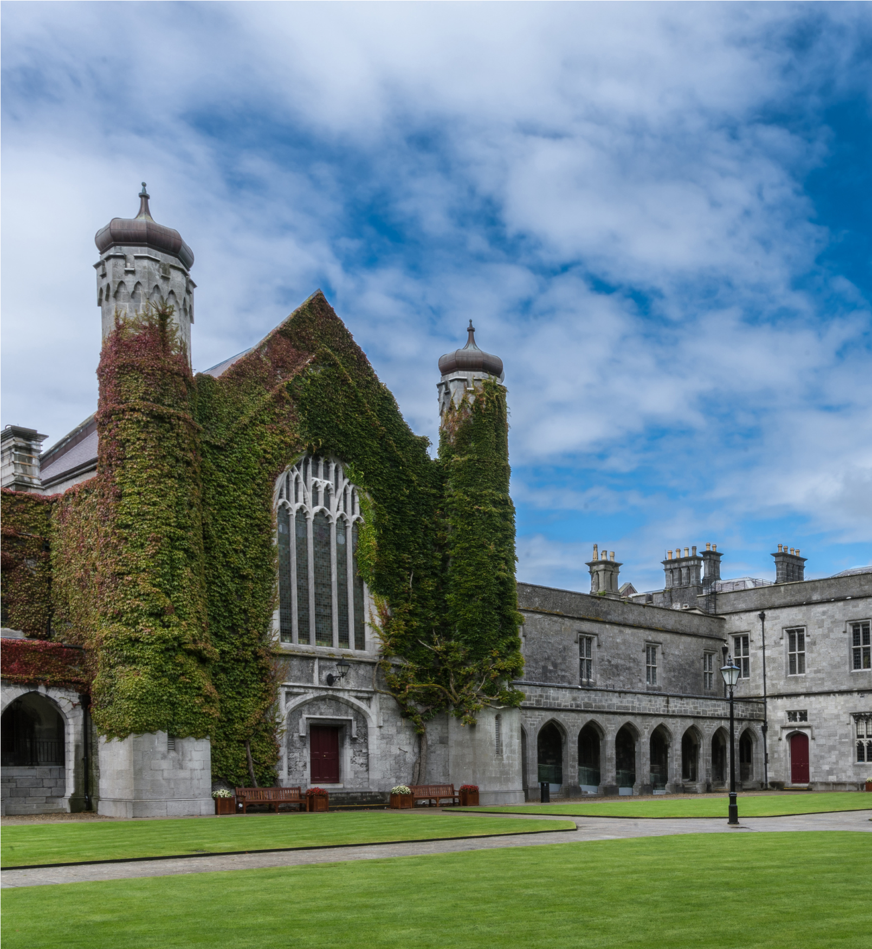

‘Lecturer
‘Duration of Post’, ‘FTE’
Contract Type A/B
Ref #:

TABLE OF CONTENTS
Page Number

Job Advertisement 4

Job Description 5

Eligibility Requirements 6

Competency Framework for Lecturer roles at University of Galway 7

Profile of the University of Galway 16-22

Lecturer
Contract Type A/B [delete as appropriate]
Title of Post
[Please complete table below]
College
School
Post Title & Subject Area
Post Duration
Level
Reports to

JOB ADVERTISEMENT

Insert details of the post here, keep text to a minimum for the advertisement.

Applications are invited for an appointment as [insert post title] at University of Galway.

For informal enquiries, please contact [insert contact name, title and name of School], Email [insert University of Galway email address] and +353 (0)91 49xxxx

Additional information on the School/Discipline/College [delete as appropriate] is available at: [insert web link]

Salary: €xxxxx to €xxxxx p.a (applicable to new entrants effective from January, 2011)
This appointment will be made on the Lecturer scale in line with current Government pay policy and in accordance with the terms and conditions of the University’s Remuneration policy. QA321-Updated-PP-Remuneration.pdf (universityofgalway.ie)
Information on the University's Strategic Plan is available at: Strategy | Straitéis 2025-30 - University of Galway

Closing date for receipt of applications is 17:00 (Irish Time) on xxxxxxxxxx. It will not be possible to consider applications received after the closing date.

Garda vetting may apply.

Appointments will be conditional on work authorisation validation.
Further details are available at www.dbei.ie

For more information and Application Form please see website:
Jobs - University of Galway Applications should be submitted online.
Please see further information on how to apply here: E-Recruit - University of Galway and Guidelines for On-line Applications (universityofgalway.ie)

Please note that appointment to posts advertised will be dependent upon University approval, together with the terms of the Employment Control Framework for the higher education sector.

At the University of Galway, we celebrate diversity and believe that every candidate can bring unique perspectives, talents and approaches to our University community. We actively encourage applications from all backgrounds regardless of race, religion, ethnicity, gender, family status, civil status, membership of the Traveller community, sexual orientation, disability or age.
We value flexibility and recognise that a work-life balance is essential. We offer flexible working arrangements, including hybrid options, to accommodate the diverse needs of our staff. Our commitment to inclusivity extends beyond recruitment as we foster a friendly and supportive work environment, where all work styles are valued and respected. Join us in shaping a workplace that thrives on diversity, creativity and collaboration.

University of Galway is an equal opportunities employer.

JOB DESCRIPTION

Principal Duties and Responsibilities

The post-holder duties will include, but not be limited to, the following:
[Insert job description e.g. of details that will be displayed are as follows:]

Teaching
To give instruction and supervision, as directed by the Head of School, to students of the University in courses and programmes organised by the School or to which the School contributes to another School or College. Such duties to include curriculum and course design, preparation and delivery of lectures, tutorials, project supervision and general examination and other assessment responsibilities. The post-holder is also required to be available to students for academic counselling and advice. In some disciplines, academic activities may also include laboratory, workshop or clinical instruction, supervision of fieldwork, site visits and other off-campus activities.

Research
To engage in research and other creative and innovative activity as appropriate to the discipline. The post-holder is required to disseminate their research in academic publications, other outlets as appropriate and to participate in postgraduate supervision. The post-holder is encouraged to engage in initiatives to seek research funding, as appropriate. The post-holder is also encouraged to promote and engage in the development of collaborative research.

Contribution and Scholarly Activity
To participate in academic administration at School, College and University levels as part of their contribution to the University. To engage with the wider community regionally, nationally and internationally from a civic, economic, social and cultural perspective as a contribution to the life of the University. In representing the University externally, the post-holder is expected to maintain the highest professional standards, thereby enhancing the reputation of the University. The post-holder is expected to engage in scholarly activity such as, but not limited to, refereeing of journals, membership of discipline related advisory bodies and peer review panels and work associated with external examinership.

The post-holder shall carry out these duties under the direction of the Head of the School or of an authorised senior member of the staff of the School.

The post-holder shall be a member of College/Colleges in accordance with University Statutes.

The hours of work are those prescribed under the Public Service Agreement in respect of Academic Staff.

ELIGIBILITY REQUIREMENTS

[Insert Eligibility requirements here, subdivide into Essential and Desirable]
Essential Requirements:
Lecturer Contract Type A
- Must have a PhD

OR

- A professional qualification in the area of proposed appointment, or evidence of significant contribution to the particular area; plus
- third-level teaching experience or a teaching qualification; plus
- A minimum of 5 years’ relevant professional experience (the third-level teaching experience will be counted towards the total 5 years “relevant professional experience”).
Some roles in the Creative areas may not be filled using the above criteria so equivalence for those areas will need to be considered.
Some roles in the area of applied clinical specialism in healthcare may not be filled using the above criteria, so equivalence for these areas will need to be considered (as approved by the College Executive)
Lecturer - Contract Type B
- Must have a PhD.

Any deviation from the above will require prior approval from the Deputy President and Registrar before being progressed for recruitment.

- Text and bullet point format.

Desirable Requirements:

- Text and bullet point format.

The appointment will be made to the School of [insert name of School], but will be associated with the discipline of [insert name of Discipline].

Appendix 1: Competency Framework for Lecturer (Contract Type A) Roles at University of Galway

 | Academic Excellence |  | Leadership Excellence |  | Organisational Excellence
CORE | - Excellence in Teaching  The Lecturer (Contract Type A) develops and delivers quality modules and courses which engage and inspire students at all levels towards deriving optimal benefit from their programmes of study. He/she is confident in using a range of teaching techniques, maintains currency with pedagogical developments and innovations in teaching in their discipline and is focused on continually developing her/his own teaching skills. | CORE | - Personal Effectiveness  The Lecturer (Contract Type A) is committed to her/his discipline and to making a high quality contribution through employing excellent planning, organising, communication and decision making skills to achieve their goals and in exercising flexibility in order to meet the multiple and changing requirements of the Lecturer (Contract Type A) role. | CAPACITY TO DEVELOP | - Strategy & Vision  The Lecturer (Contract Type A) should contribute to the strategic development of the discipline through an awareness of the wider educational environment, maintaining currency with developments in the discipline and how the School/Discipline can develop in the long term to optimise its contribution to the University’s programmes. He/She must have the ability to develop proposals for the development of new modules and courses and engage in interdisciplinary initiatives towards the development of the School/Discipline.
CORE | - Excellence in Associated Research  The Lecturer (Contract Type A) keeps up to date with research developments in her/his field and incorporates same into teaching as appropriate. He/she engages in the scholarship of teaching. | CAPACITY TO DEVELOP | - Leading Others  The Lecturer (Contract Type A) must work well with others, providing leadership and direction to students and colleagues in relation to projects or areas of work that they are leading on. In such instances they effectively encourage, support and manage the contributions of others to deliver a project/programme of work to a high level. | DEVELOPING | - Collegiate & Community Contribution  The Lecturer (Contract Type A) values and engages in a collegiate approach to working with others, within their own discipline, School, College and University and also within the wider external community. He/She actively seeks to build effective networks and is willing to contribute their time and expertise to University projects.

Competencies for Lecturer (Contract Type A) Role in University of Galway

ACADEMIC EXCELLENCE
Competency 1: Excellence in Teaching
The Lecturer (Contract Type A) develops and delivers quality modules and courses which engage and inspire students at all levels towards deriving optimal benefit from their programmes of study. He/she is confident in using a range of teaching techniques, maintains currency with pedagogical developments and innovations in teaching in their discipline and is focused on continually developing her/his own teaching skills.
- Provides a high standard of teaching to students across a range of programmes in their discipline
- Provides mentoring and supervision to undergraduate and post graduate students / projects / programmes as required
- Leads on/contributes to the development and review of the curriculum and programmes delivered and encourages other staff to contribute
- Works to keep programmes ‘fresh’ and maintains currency of programmes informed by research
- Confident teaching student groups of various sizes and at different levels
- Competent and consistent in setting and organising/co-coordinating the marking of examinations
- Demonstrates, through their teaching, strong enthusiasm for their subject area and a high level of up to date knowledge and expertise in their area
- Competent in a range of teaching methods and strategies and is willing to continually evaluate and develop their teaching methods and skills, looking for better ways of teaching
- Open to using technological innovation as part of their teaching and keeps up-to-date with developments in this area
- Organises and structures their teaching logically to help maximise learning and ensure a good student experience
- Demonstrates a commitment to students and gives the time and effort to engage with, and be accessible to students
- Has the ability to give constructive and timely feedback and advice to students
- Balances a concern for students with a focus on being consistent and equitable in their treatment
- Benchmarks against those relevant programmes in other universities and aims to ensure that programmes are of a high standard
- Works with students to promote ideas of academic integrity, including the avoidance of plagiarism
- Embraces new modes of teaching and learning

Competency 2: Excellence in Associated Research
The Lecturer (Contract Type A) keeps up to date with research developments in her/his field and incorporates same into teaching as appropriate.
- Keeps up to date and maintains currency with associated research that furthers the School / Discipline
- Contributes to and supports the research priorities and activities at School / Discipline level
- Builds up collaborative links and networks with external organisations and keeps up to date with research and what is happening in the relevant international research area
- Attends relevant conferences, and works with industry and other relevant external bodies to keep knowledge relevant
- Provides supervision and guidance in relation to the research of students, motivating and encouraging them to help them overcome problems
- Engages/seeks opportunities in the scholarship of teaching and learning

LEADERSHIP EXCELLENCE
Competency 3: Personal Effectiveness
The Lecturer (Contract Type A) is committed to her/his discipline and to making a high quality contribution through employing excellent planning, organising, communication and decision making skills to achieve their goals. He/She will exercise flexibility in order to meet the multiple and changing requirements of the Lecturer (Contract Type A) role.
- Demonstrates excellent planning, organisation and prioritisation skills, to effectively meet deadlines and to deliver to high standards across the areas of teaching, associated research and administration
- Has good time management skills to manage workload
- Has a reflective approach to their own work and can consistently review it in order to ensure it is of a high standard
- Flexible and adaptable in managing competing demands while protecting core values
- Shows a strong commitment to keeping up to date and maintaining professional competence
- Is resilient and maintains a positive outlook in challenging and pressurized circumstances
- Takes a balanced approach to the demands of the role and is flexible with what the role encompasses
- Understands the importance of programme innovation, related budget management and raising programme funds

Competency 4: Leading Others
The Lecturer (Contract Type A) must work well with others, providing leadership and direction to students and colleagues in relation to projects or areas of work that they are leading on. In such instances they effectively encourage, support and manage the contributions of others to deliver project/programme of work to a high level.
- Works constructively within a collective collegiate structure
- Consistently works with others to ensure high standards in all aspects of the role
- Is able to get the most of out of people and to secure their support and cooperation in relation to work they are leading/managing
- Gives clear instructions in relation to the contribution expected from others
- Has the ability to manage and encourage others to deliver what is required
- Actively supports the career development of students and newer colleagues
- Organises and delegates work in a way which is consistent and fair and makes best use of resources
- Understands the importance of, and can use a range of strategies to, motivate students and colleagues
- Takes the initiative to put good ideas into practice

ORGANISATIONAL EXCELLENCE
Competency 5: Collegiate and Community Involvement

The Lecturer (Contract Type A) values and engages in a collegiate approach to working with others, within their own discipline, School, College and University and also within the wider external community. He/She actively seeks to build effective networks and is willing to contribute their time and expertise to University projects.
- Actively builds strong internal and external networks and collaborative links
- Takes time to build up positive working relationships with others and treats everyone fairly and with respect
- Assumes administrative/organisational roles and tasks to help ensure the smooth running of the School/Discipline
- Acts as chair on committees or acting as representative at school/college/university level and works to develop the skills needed to perform these roles effectively
- Makes an effort to understand and take account of different people’s views and perspectives
- Encourages students to get involved in relevant external groups also, where appropriate
- Supports colleagues internally and cooperates with other universities in initiating collaborative programmes
- Possess the skills required to achieve a balance between internal requirements and external requirements
- Participate in relevant professional organisations/networks as appropriate

Competency 6: Strategy and Vision
The Lecturer (Contract Type A) should contribute to the strategic development of the discipline through an awareness of the wider educational environment, maintaining currency with developments in the discipline and how the School/Discipline can develop in the long term to optimise its contribution to the University’s programmes. He/She must have the ability to develop proposals for the development of new modules and courses and engage in interdisciplinary initiatives towards the development of the School/Discipline.

- Has a clear overall vision for what the School/Discipline is trying to achieve and how their work fits in with the overall direction
- Understands how the discipline is developing and brings this to bear on their work
- Undertakes relevant benchmarking against other organisations and avails of opportunities to increase understanding of best practice
- Identifies opportunities for new modules and programmes by assessing what will be viable and of interest in the long term
- Creates, and takes advantage of, opportunities to market programmes to attract high quality students
- Able to negotiate whilst recognising the realities and the resource restrictions and is willing to change and adapt to meet future needs

Appendix 2: Competency Framework for Lecturer (Contract Type B) Roles at University of Galway

 | Academic Excellence |  | Leadership Excellence |  | Organisational Excellence
CORE | - Excellence in Research  The Lecturer (Contract Type B) furthers their discipline and contributes to the body of knowledge in their area through planning, carrying out and publishing/ disseminating their own high quality research, building and leading research groups and providing supervision and support for postgraduate students to enable them to produce quality research. They keep up to date with relevant developments in their field and network and collaborate with others, both internally and externally, to optimise the value and relevance of the research being produced and to maximise the School’s/Discipline’s ability to attract research funding. | CORE | - Personal Effectiveness  The Lecturer (Contract Type B)is enthusiastic about their discipline and is committed to making their best personal contribution through employing excellent planning and organising, communication and decision making skills to achieve their goals and through working hard and being flexible in order to meet the multiple and changing demands of the Lecturer (Contract Type B) role. | CAPACITY TO DEVELOP | - Strategy & Vision  The Lecturer (Contract Type B)should contribute to the strategic development of the discipline by developing a strong awareness of the wider environment, how the discipline is developing and how the School/Discipline can develop in the long term to optimise its contribution. He /She must have the ability to make a strong case for the development of new programmes or engaging in joint programmes or collaborations that they feel will add long term value to the School/Discipline.
CORE | - Excellence in Teaching  The Lecturer (Contract Type B) develops and delivers quality teaching programmes which engage and inspire students at all levels and maximises their learning. They are confident in using a range of teaching techniques, are open to innovations in teaching and are focused on continually developing their own teaching skills. | CAPACITY TO DEVELOP | - Leading Others  The Lecturer (Contract Type B) must work well with others, providing leadership and direction to students, colleagues and support staff in relation to projects or areas of work that they are leading on. They effectively encourage, support and manage the contributions of others to deliver results for the discipline and to ensure that high standards are met. | DEVELOPING | - Collegiate & Community Contribution  The Lecturer (Contract Type B) values and engages in a collegiate approach to working with others, within their own discipline, school and university and also within the wider external community. S/he actively seeks to build effective networks and is willing to contribute their time and expertise to a range of broader university wide or community projects.

Competencies for Lecturer (Contract Type B) in University of Galway

ACADEMIC EXCELLENCE
Competency 1: Excellence in Research
The Lecturer (Contract Type B) furthers their discipline and contributes to the body of knowledge in their area through planning, carrying out and publishing/ disseminating their own high quality research, building and leading research groups and providing supervision and support for postgraduate students to enable them to produce quality research. They keep up to date with relevant developments in their field and network and collaborate with others, both internally and externally, to optimise the value and relevance of the research being produced and to maximise the School’s/Discipline’s ability to attract research funding.
- Conducts high quality research that furthers the School / Discipline
- Publishes research frequently in high quality, peer-reviewed journals and presents research at high profile conferences
- Builds up collaborative links and networks with other organisations and keeps up to date with research in own area and what is happening in the international research community
- Goes to relevant conferences, and works with industry and other relevant external bodies to keep research relevant
- Writes strong research and grant proposals which sells the value and potential benefits of a piece of research
- Effectively plans research and can estimate the time and resources required to complete it, and delivers on schedule
- Provides quality supervision and guidance in relation to the research of undergraduate and postgraduate students, motivating and encouraging them to help them overcome problems

Competency 2: Excellence in Teaching
The Lecturer (Contract Type B) develops and delivers quality teaching programmes which engage and inspire students at all levels and maximises their learning. They are confident in using a range of teaching techniques, are open to innovations in teaching and are focused on continually developing their own teaching skills.
- Provides a high standard of teaching to students across a range of programmes in their discipline
- Provides mentoring and supervision to PhD students / projects / programmes as required
- Leads on/contributes to the development and review of the curriculum and programmes delivered and encourages other staff to contribute
- Confident teaching student groups of various sizes and at different levels
- Competent and consistent in setting and organising/co-ordinating the marking of examinations
- Demonstrates, through their teaching, strong enthusiasm for their subject area and a high level of up to date knowledge and expertise in their area
- Competent in a range of teaching methods and strategies and is willing to continually evaluate and develop their teaching methods and skills, looking for better ways of teaching
- Open to using technological innovation as part of their teaching and keeps up-to-date with developments in this area
- Organises and structures their teaching logically to help maximise learning and ensure a good student experience
- Keep students engaged by incorporating research and current topics into teaching and informing their teaching by what is going on in the wider environment and including external input
- Demonstrates a commitment to students and gives the time and effort to engage with, and be accessible to students
- Has the ability to give constructive and timely feedback and advice to students
- Balances a concern for students with a focus on being consistent and equitable in their treatment
- Benchmarks teaching programmes against those in other universities and aims to ensure they are of a high standard
- Works with students to prevent plagiarism, and puts systems in place to detect and manage plagiarism

LEADERSHIP EXCELLENCE
Competency 3: Personal Effectiveness
The Lecturer (Contract Type B) is enthusiastic about their discipline and is committed to making their best personal contribution through employing excellent planning and organising, communication and decision making skills to achieve their goals and through working hard and being flexible in order to meet the multiple and changing demands of the Lecturer (Contract Type B) role.
- Demonstrates excellent planning, organisation and prioritisation skills, to effectively meet deadlines and to deliver to high standards across the areas of teaching, research and administration
- Has good time management skills to manage a heavy workload
- Demonstrates clear commitment and is willing to work hard for the success of their area
- Has a reflective approach to their own work and can consistently review it in order to ensure it is of the highest possible standard
- Active in reviewing systems and processes to maximise the time available for research and teaching
- Flexible and adaptable in managing competing demands while protecting core values
- Shows a strong commitment to keeping up to date and maintaining professional competence
- Is resilient and maintains a positive outlook in a challenging and pressurised environment
- Takes a balanced approach to the demands of the role and is flexible with what the role encompasses
- Understands the importance of budget management and raising programme funds, and can assimilate financial information and report back on financial matters

Competency 4: Leading Others
The Lecturer (Contract Type B) must demonstrate a capacity to develop skills and competence to work well with others, providing leadership and direction to students, colleagues and support staff in relation to projects or areas of work that they are leading on. They effectively encourage, support and manage the contributions of others to deliver results for the discipline and to ensure that high standards are met.
- Works constructively within a collective collegiate structure
- Consistently works with others to ensure high standards in all aspects of the role
- Is able to get the most of out of people and to secure their support and cooperation in relation to work they are leading/managing
- Gives clear instructions in relation to the contribution expected from others
- Has the ability to manage and encourage others to deliver what is required
- Actively supports the career development of postgraduate students and newer colleagues
- Organises and delegates work in a way which is consistent and fair and makes best use of resources
- Understands the importance of, and can use a range of strategies to, motivate students and support staff and colleagues
- Takes the initiative to put good ideas into practice

ORGANISATIONAL EXCELLENCE

Competency 5: Collegiate and Community Contribution
The Lecturer (Contract Type B) values and engages in a collegiate approach to working with others, within their own discipline, school and university and also within the wider external community. S/he actively seeks to build effective networks and is willing to contribute their time and expertise to a range of broader university wide or community projects.
- Actively builds strong internal and external networks and collaborative links
- Participates in cross discipline working groups in addition to taking on roles in external institutions/agencies (with the necessary University approval in place)
- Takes time to build up positive working relationships with others and treats everyone fairly and with respect
- Assumes administrative/organisational roles and tasks to help ensure the smooth running of the School/Discipline
- Acts as chair on committees or acting or as representative at school/college/university level and works to develop the skills needed to perform these roles effectively
- Makes an effort to understand and take account of different people’s views and perspectives
- Contributes outside the university to different committees, the local community, and voluntary organisations
- Encourages students to get involved in relevant external groups also, where appropriate
- Supports colleagues internally and with other universities in initiating collaborative enterprises/programmes
- Possess the negotiation skills required to achieve a balance between the university’s academic requirements with potentially competing requirements of external bodies

Competency 6: Strategy and Vision
The Lecturer (Contract Type B) should demonstrate a capacity to develop skills and competence to contribute to the strategic development of the discipline by developing a strong awareness of the wider environment, how the discipline is developing and how the School/Discipline can develop in the long term to optimise its contribution. He /She must have the ability to make a strong case for the development of new programmes or engaging in joint programmes or collaborations that they feel will add long term value to the School/Discipline.
- Has a clear overall vision for what the School/Discipline is trying to achieve and how their work fits in with the overall direction
- Understands how the discipline is developing and brings this to bear on their work
- Uses initiative to benchmark against other organisations and takes other opportunities to increase understanding of best practice across the system
- Knows what research is being done within their area and what type of research will attract funding from which sources
- Identifies opportunities for new modules and programmes by assessing what will be viable and of interest in the long term
- Uses judgement to build and sell a persuasive case for resources/new programmes on behalf of their area/college
- Creates, and takes advantage of, opportunities to market programmes to attract high quality postgraduate students
- Able to negotiate for an area while recognising the realities and the resource restrictions and is willing to change and adapt to meet future needs

Ollscoil na Gaillimhe
University of Galway
PROFILE OF THE UNIVERSITY
The University at a Glance:
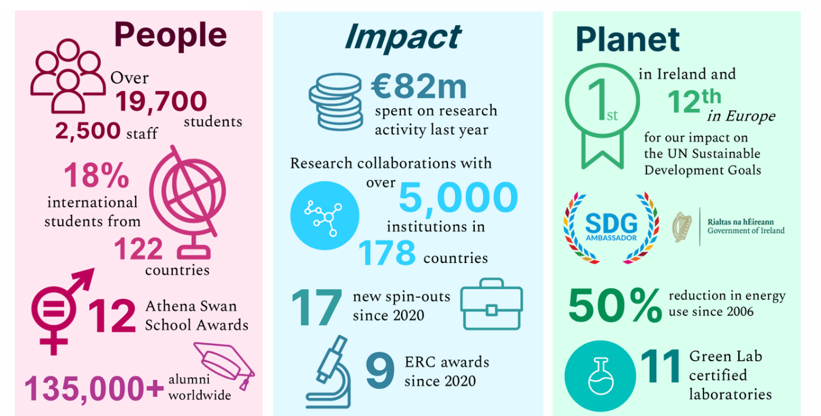
The University Management Team
The University Management Team (UMT) is responsible for the executive day-to-day management of the University. UMT is led by the President who is the Head and Chief Officer of the University. Professor David Burn is President of University of Galway. You can read more about him at: www.universityofgalway.ie/president
Acting under the President, the members of the University Management Team (UMT) each have specific leadership responsibilities for delivery of the University’s objectives in education, research and management of the organisation. You can see the full UMT membership in the organisational chart above.
Find out more about the University’s Governance and Management structures at: www.universityofgalway.ie/governance/the-kube-the-governance-hubhttp://www.universityofgalway.ie/governance/the-kube-the-governance-hub
Colleges and Schools
The University has four Colleges:
  - College of Arts, Social Sciences & Celtic Studies
  - College of Business, Public Policy & Law
  - College of Medicine, Nursing & Health Sciences
  - College of Science & Engineering
Each of the Colleges is led by an Executive Dean. Within each College, decisions are taken by College Boards, chaired by the Executive Dean, and including the Heads of each School in the College.
For more information on Colleges, Schools and Disciplines, visit:
www.universityofgalway.ie/colleges-and-schools

College | Schools
College of Arts, Social Sciences &  Celtic Studies  College of Business, Public Policy  & Law  College of Medicine, Nursing &  Health Sciences  College of Science & Engineering | School of Political Science & Sociology  School of Psychology  School of Education  School of Geography, Archaeology & Irish Studies  School of English & Creative Arts  School of History & Philosophy  School of Languages, Literatures, & Cultures  J.E. Cairnes School of Business & Economics  School of Law  Shannon College of Hotel Management  School of Health Sciences  School of Medicine  School of Nursing & Midwifery  School of Biological & Chemical Sciences  School of Computer Science  School of Engineering  School of Mathematical & Statistical Sciences  School of Natural Sciences
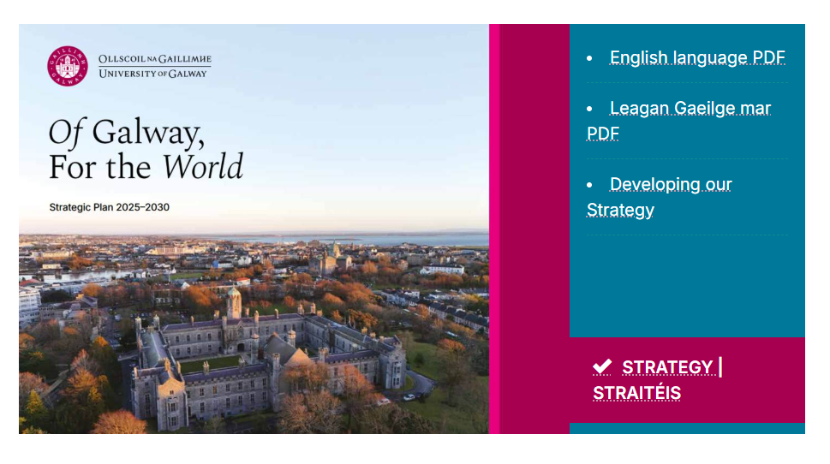
  - You can read the strategic plan at: Strategy | Straitéis 2025-30 - University of Galway

Our new strategic plan was developed through 18 months of consultation with our university community, with external partners in our city and region, and with the input of experts and supporters from around the world. Despite the diversity of inputs, the message was consistent:
- Be clear in our purpose and our core activities
- Communicate our distinctiveness
- Demonstrate our global impact
- Invest in our organisation to make it an effective university to work in and work with.

Our new strategy focuses on our core mission as a university to nurture talent and generate knowledge for the world. It articulates our ambition to make a distinctive impact through our research and innovation. It demonstrates our drive to enhance our education for the future, both in the excellence of our teaching and learning and the quality of our student experience. And it commits us to investing in our organisation and infrastructure to make it a more effective, sustainable and empowering place for our people.

We have stated these ambitions clearly and concisely. We now warmly welcome the engagement of our university community,
and we invite the community to respond in inspiring and impactful ways. And we invite and encourage partners who share our vision to reach out and join us on our journey.
Building upon our strategic priorities, we have used this opportunity to engage staff, students and partners to define what makes us stand out, in terms of:
- Our Distinctive Place
- Our Research Pillars
- Our Galway Graduates

These have been informed by our shared experience of working and studying in University of Galway, and by external perspectives of our reputation. We will use this framework to guide us in our strategic planning and to communicate our distinctiveness with the world.
To give confidence to our community and partners that we listened to your feedback, we have also detailed where we plan to invest in our organisation in our Priority Initiatives and where we will evidence the impact of our actions in our Measures of Success.
In such a large and complex organisation, we have identified those Key Enablers that support excellence across our activities. Guiding us in our actions, and setting standards of behaviour for our university, our people and partners, we have articulated five Core Values informed by student and staff feedback: Excellence, Respect, Openness, Sustainability, and Belonging.
Student Body
The total student body, including part-time learners, comprises over 20,000 students, over 25% of whom are studying at postgraduate level.
Over 18% of our students were from outside the island of Ireland, coming to study in Galway from over 122 different countries worldwide. Through the Global Galway project, we are seeking to grow our international diversity further through a greater focus on international recruitment, mobility and partnerships.
Research
University of Galway is a globally focused research-intensive university. We recognise that research areas are neither standalone nor static. The problems of the world are not solved from just one perspective. With our knowledge of global challenges, national policy and regional needs our research areas enable an interdisciplinarity approach and impact.
Our research community achieved over €110m in EU research funding during the 2014-2020 programme period. We are now firmly focused on the 2021-2027 programme cycle, with ambitions to achieve in excess of €150m of EU research funding, including Horizon Europe. In 2023, the University had a record €82m annual spend in research, across a breadth of research areas. Engaging with our partners locally, nationally and worldwide, our current university strategy (Strategic Plan 2020-2025) invites ambition in research that underpins the following areas:
  - Enhancing policy and society
  - Enriching creativity and culture
  - Improving health and wellbeing
  - Realising potential through data and enabling technologies
  - Sustaining our planet and people
These areas are aligned to the work of our Research Institutes, including:
  - Data Science Institute
  - Ryan Institute for advancing sustainability and innovation
  - Institute for Lifecourse and Society
  - Institute for Creativity
  - Institute for Clinical Trials
  - Institute for Health Discovery and Innovation (launched in October 2024).

For more information on our research institutes, centres and units, visit:
www.universityofgalway.ie/our-research/listings/research-centres-institutes-and-units.html

Staff
The University employs approximately 2,500 staff, including full-time and part-time, which includes approximately 1,000 academic staff.
Human Resource issues are managed within the Human Resources Office, under the direction of the Director of Human Resources. In 2023, a new Hybrid Working Policy was launched to facilitate more flexible working arrangements in a post-Covid environment.

Finances
The University is its own financial authority and has an annual income of over €350m, including contract research income of over €70m. The sources of income are Student Fees (approx. 40%), State Grants and Pension funding (approx. 30%), Research Income (20%) and Miscellaneous (10%).

The University and the Irish language
The University’s commitment to the Irish language was first set out in the University College Galway Act 1929 and this was reiterated in the University College Galway (Amendment) Act 2006, which states that one of the principle aims of the university is “the provision of education ... through the medium of the Irish language”.
The University’s Strategy 2020-2025 goes even further and commits to developing and implementing an ambitious and future-focused strategy for the Irish language, in partnership with national stakeholders and Gaeltacht communities, based on our values of respect and sustainability. In 2021, the University published its first Irish Language Strategy and appointed its first Irish Language Officer.

Irish language programmes are delivered primarily through the Discipline of Irish and through Acadamh na hOllscolaíochta Gaeilge, our Irish language academy, which has three centres located in the Gaeltacht.

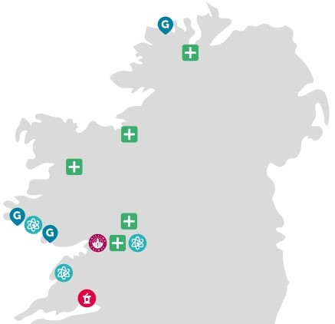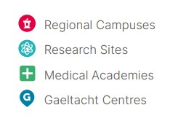

Our Region
Our regional footprint includes five Medical Academies, three Gaeltacht centres, off-campus research sites in Connemara and the Burren, and a satellite campus in Shannon College, Co. Clare.
Our Campus
The main University Campus, with an area of some 105 hectares in the heart of the city of
Galway, is attractively situated on the west bank of the River Corrib, and stretches from Nuns' Island in the south to the Sports Grounds in Dangan to the north. Other teaching and research facilities are located outside the city in An Cheathrú Rua, Carna and Mace Head in Connemara, in Shannon, Carron and Finnevara in Co. Clare, and in Gaoth Dobhair in Co. Donegal. The University’s medical students and researchers benefit from on-the-ground Medical Academies located in hospitals throughout the region from Portiuncula University Hospital in Co. Galway to Letterkenny University Hospital in Co. Donegal.

Building for the Future: The University is in the process of finalising its masterplan for the years ahead, which will include the Nuns’ Island creative and innovation district in Galway city centre. Recent years have seen some significant additions to campus, including:
- Clinical Simulation Facility: completed in 2022
- Dunlin Village on-campus student accommodation (674 beds): completed in 2022
The following construction projects have been commenced or approved in recent years:
- Learning Commons (new Library): construction commenced in 2024
- Water Sports Centre: planning permission approved in 2023
- New Law School: design for planning in progress
- New Pharmacy School: funded to planning stage
- New Medical School: funded to planning stage

Sustainability
Sustainability is one of the University’s core values and we are recognised as a leader in the transition to a sustainable future. We are committed to the SDGs at an institutional level on multiple levels:
- As a signatory to the SDG Accord, we have committed ‘to align all major efforts with the SDG targets and indicators, including through our education, research, leadership, operational and engagement activities’ and to ‘share our learning’.
- Our Climate Action and Sustainability Policy formalises our commitment ‘to lead the transition to a sustainable future by embedding the SDGs into all our major efforts’.
- Our Sustainability Strategy 2021-2025, which is mapped to the SDGs, sets out our vision across the campus and beyond.
In the past three years we have been ranked First in Ireland and Top 50 worldwide in the Times Higher Education Impact Rankings for our progress on the SDGs. In 2023, we established a new Sustainability Office to lead the implementation of our Sustainability Strategy and to embed sustainability across our curriculum and operations.
Through the work of the University’s Sustainability Office, the Community and University Sustainability Partnership, colleagues in Buildings and Estates and other university operations, and our Student Societies, we have advanced understanding and action on the urgent need for sustainability, using a Learn – Live – Lead model. Since 2006, we have achieved over 50% reduction in energy usage, exceeding our targets. In 2021, we established our carbon footprint, and we are actively working towards achieving carbon neutrality by 2050.

