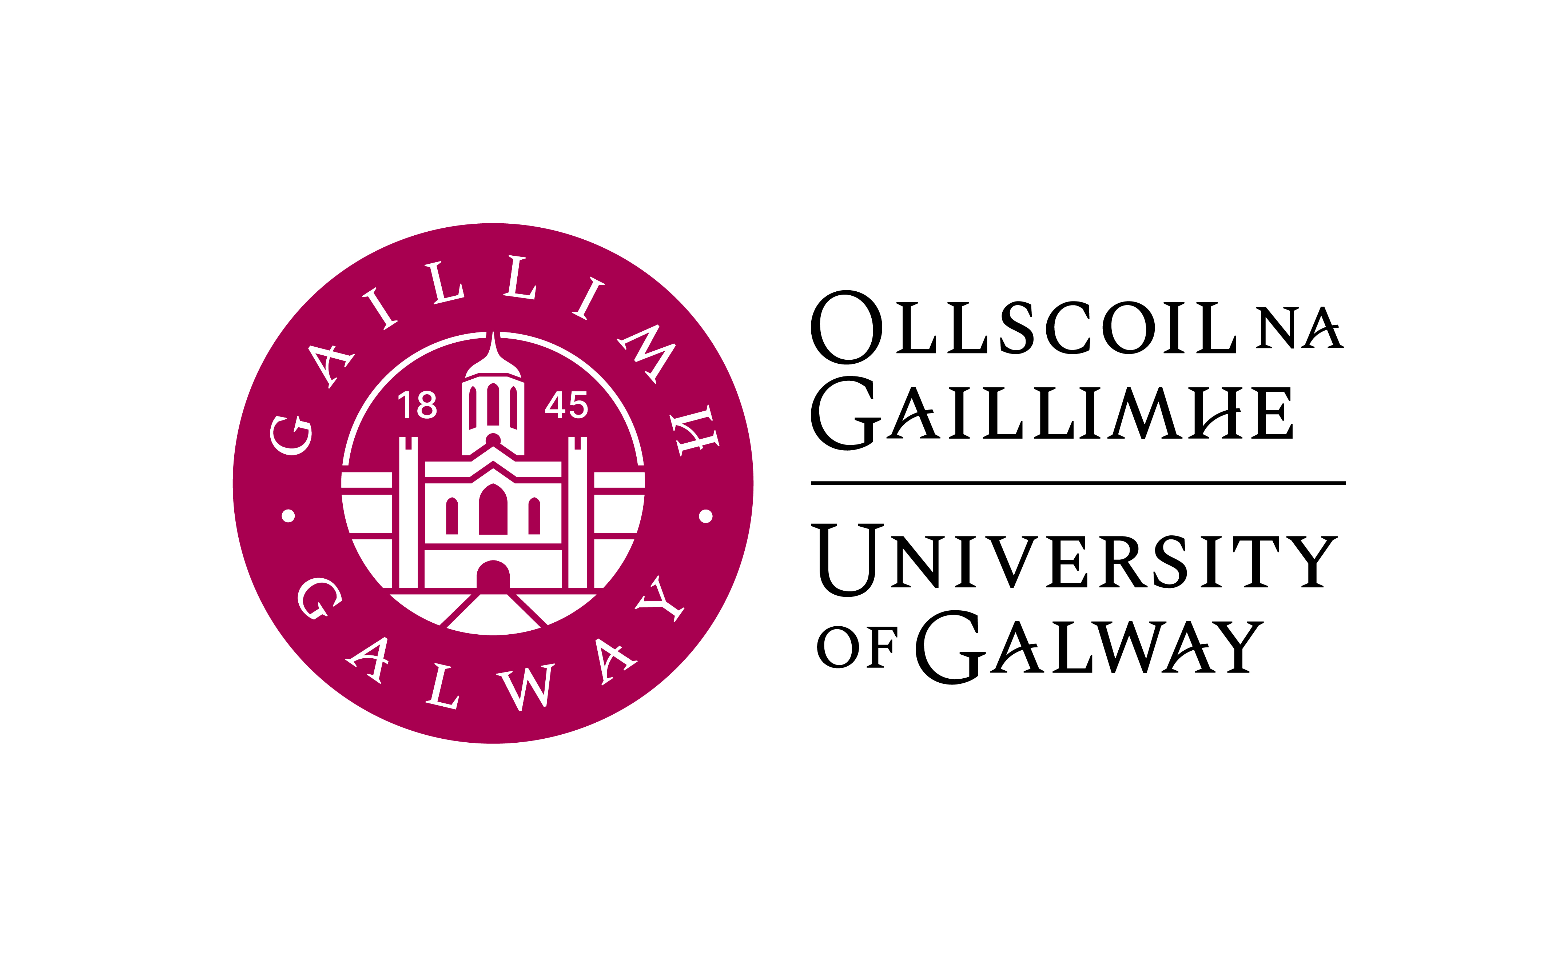

GR 141 1BC1 & 1BC3 & 1BC8
FIRST YEAR (ADVANCED) COMMERCE WITH GERMAN

First year (Advanced) Commerce with German is available to:
- students who applied through the CAO for the B.Comm (International) with German programme 1BC3. Entry requirement: H4 or better.
- students of the first year Commerce (General) programme 1BC1 and Commerce (Global Experience) programme 1BC8. Entry requirement: Leaving Certificate German)

Course Coordinator: Dr Jeannine Jud-Kelly
Email: jeannine.jud@universityofgalway.ie
Office: Arts Millennium Building (AMB) 2001

Lecturers: Dr Jeannine Jud-Kelly (German Grammar), contact details as above

Anne Kathrin Bock (German Language, Business German, Landeskunde)
Email:tbc
Office: Arts Millennium Building (AMB) 2045

Vincent O’Connell (Conversation/Multimedia Lab)
Email: vincent.oconnell@universityofgalway.ie
Office: Arts Millennium Building (AMB) 2005

Course Outline:
5 contact hours per week (Semester 1 & 2) are made up of:
- German Language I & Grammar (3 hours per week)
- Society, culture & the economy in the German-speaking world (1hr per week)
- Conversation & multimedia laboratory (1 hr per week)

Course Aims and Objectives:
Students will follow a course which is designed to:
- build and expand on the German language skills they already possess
- develop the ability to express ideas and argue convincingly in oral and written German
- expand existing vocabulary and introduce new business terminology
- develop the linguistic skills necessary to successfully take and pass level A2+ (CEFR) university examinations
- facilitate insights into cultural and social issues currently discussed in German-speaking countries through authentic course materials from German-language sources in a range of media
- use continuous assessment and regular feedback to motivate students to participate actively and engagingly with their chosen language
- convey a general understanding of social, political, economic and cultural affairs in the German-speaking world

Learning Outcomes:

After the end of the academic year, first year students should be able to:
- understand and feel comfortable with the use of general structures of German grammar in oral and written expression
- make basic oral presentations in German on a variety of general and business- related topics
- form opinions and discuss basic general and business-related topics
- translate a variety of simple texts into English and German, using appropriate grammatical structures
- analyse different types of texts in German and discuss text-related questions
- read and answer basic general and business correspondence as well as compose argumentative and descriptive writing on a variety of topics
- use self-study and multimedia laboratory facilities for autonomous learning and project work
- have a basic understanding of culture and civilisation in German-speaking countries
- relate to contemporary social and economic affairs in German-speaking countries.

Learning and Teaching Methods:

The programme actively engages students in the learning process, encouraging participation from the outset. Small class size, role-plays, group discussions, presentations, project work and an open and student-centred learning approach facilitate a productive and communicative learning environment.
The extensive use of authentic materials, such as newspaper and magazine articles, and audio-visual sources ensure the contemporary focus of the curriculum. Guided self-study on the VLE and multimedia laboratories provide access to Internet resources and multimedia language applications.
The language of instruction and communication is predominantly German, ensuring that students are from the beginning exposed to the target language.
All students are expected to access the Virtual Learning Environment Canvas regularly, where they can find announcements, assignment instructions and submission areas, teaching notes and slides, links to online resources on language and society, video and audio materials as well as discussion forums.

Textbooks (required):
A-Grammatik  2nd edition, 2023 | Übungsgrammatik, ISBN 9783969150573 | Publisher:  Schubert | Semester 1 & 2
Begegnungen A2+  3rd edition, 2021 | Kurs- und Arbeitsbuch, ISBN 9783969150085 | Publisher:  Schubert | Semester 1 & 2
Both books will be available in the campus bookshop. Additional materials will be provided on Canvas and in class.

Course elements:

  - Grammar:
In first year, students will receive and will put into regular practice a detailed revision of all basic elements and structures of German grammar, syntax, punctuation and orthography up to CEFR level A2+.

Introduction to Business German:
An introduction to the topics, language, vocabulary and structures used in everyday business dealings in the German-speaking world (level A2+).

Reading skills:
Analysis of various types of texts and selective reading with prepared and authentic texts from newspapers, magazines and online sources. Introduction to surface, selective and detailed reading skills as well as business texts.

Writing skills:
Introduction to various writing skills in the general and business contexts, e.g. informal and formal correspondence, essay and free composition on general and business-related topics, basic job applications etc.

Conversation:
General conversation and discussions on a variety of topics including family and friends, student life, demographics, living arrangements, work and finance, plans for the future, media and multimedia, social networking, travel in Europe etc.

Presentations:
Students will receive a detailed introduction on how to make successful general and formal presentations. All students will have the opportunity to give class presentations on a cultural/business topic. These presentations will equip students with transferable skills applicable to other academic subjects and job interviews.

Multimedia laboratory:
Students work with audio and multimedia applications to perfect existing language skills and expand on newly acquired skills. The use of Web 1.0 (Internet) and Web 2.0 (blogs, podcasts, social networks) technologies also helps students to gain insight into cultural and social aspects of the German-speaking world as well as engage in autonomous learning.

Society, culture and economy in the German-speaking world:
Students are introduced to important aspects of German, Austrian and Swiss culture and society. Students will analyse basic economic affairs and developments in the German-speaking world. A brief introduction to Liechtenstein will also be provided.

Exams and Assessments:

First year students take their German written examination at the end of the academic year. There is also an in-house oral examination towards the end of the teaching period in Semester 2.
Continuous online and in-class assessment throughout the academic year is a vital part of the course. Grades are also awarded for participation and project work.

Allocation of Marks:

Semester 1:
ECTS 5.0

Final In-House Exam 30%
Mid-term In-House Exam 20%
Language Lab/Conversation 15%
Landeskunde 15%
Graded coursework assignments 20%

Semester 2:
ECTS 5.0

Applied German Language Paper (2 hrs. written exam) 30 %
Oral Examination 20 %
Language lab 15 %
Oral Presentation 15 %
Graded coursework assignments 20 %

Repeat Examinations:

In-house examinations and/or language tests cannot be repeated in the August examinations. Coursework and in-house assessments completed during both semesters cannot be carried forward to the August repeat examinations as assessment is based on performance in the examinations (written and oral) only.

