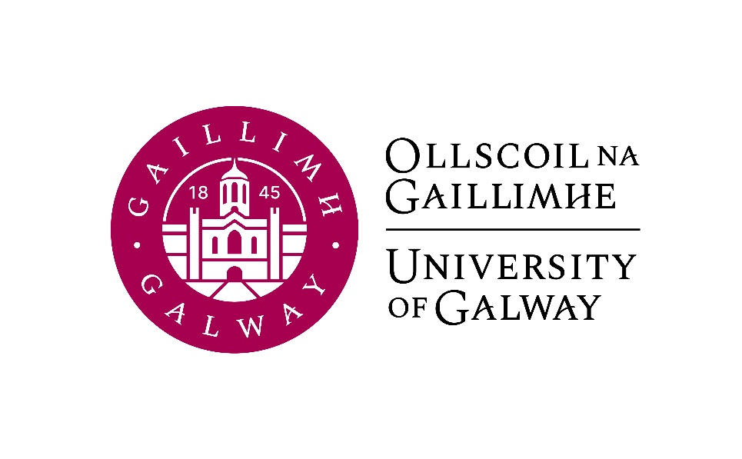

Final Year Arts
German
Course Booklet

2025-2026

Head of Discipline and Final Year Co-ordinator: Dr. Deirdre Byrnes, Room AMB-2003
Email: deirdre.byrnes@universityofgalway.ie

Discipline Administrator: Natalie Nevin, Room AMB-2006
Email: natalierebecca.nevin@universityofgalway.ie

Discipline of German website: https://www.universityofgalway.ie/german/

 | Academic Year 2025–2026
2025 (Semester 1)
Start of teaching | Monday 8th September
End of teaching | Friday 28th November
Study Week | Monday 1st December – Friday 5th December
Semester 1 Exams | Monday 8th December – Friday 29th December
Christmas Holidays | Start Saturday 20th December
2026 (Semester 2)
Start of Teaching | Monday 12th January
End of Teaching | Thursday 2nd April
Easter | Good Friday 3rd April to Easter Monday 6th April
Field Trips | Monday 7th April to Friday 10th April
Study Week | Friday 13th April to Friday 17th April
Semester 2 Exams | Tuesday 21st April – Friday 8th May
Autumn Repeat Exams | Tuesday, 4th August to Friday 14th August
Holidays | Easter: Good Friday 3rd April to Easter Monday 6st April
 | Bank Holidays: Monday 27th October 2025/Monday 2nd February 2026/Tuesday, 17th March 2026/ Monday 4th May 2026/ Monday 1st June 2026 / Monday 3rd August 2026

SEMESTER 1
All modules have the value of 5 ECTS.

Module | Component(s)
GR341 German Language I
GR337 German Studies I  Students must choose Sociolinguistics of German plus one of the optional components. | Sociolinguistics of German 50%  AND  Voices of Postmigration in Germany 50%  OR  Contemporary German Crime Fiction on TV and in LIterature 50%
GR338 German Studies II | Memory in Contemporary German Literature
SEMESTER 2
All modules have the value of 5 ECTS.

Module | Component(s)
GR342 German Language II
GR339 German Studies III | German Theatre Production  OR  Christa Wolf: Kindheitsmuster 100%
GR340 German Studies IV | German Literature and Ecology

Important information about in-house assessments:
A medical certificate or the approval of an extenuating circumstance is required for a student to be able to sit the in-class test at a later date. More information regarding the Extenuating Circumstances Policy can be found here: https://www.universityofgalway.ie/colleges-and-schools/arts-social-sciences-and-celtic-studies/student-information/studentformsandlinks/

SEMESTER 1
GR341 | German Language I (4 hours per week)

Lecturers: Tina-Karen Pusse, Maybritt Bonifer
Course description:
This course will further develop the language skills acquired in second year and refine your understanding of German vocabulary, communication and sentence structures. The aim is to advance your ability to speak and write correctly, fluently and accurately in typical communication situations, while also enhancing your reading and listening skills. Language learning activities include group discussions, individual Stellungnahmen, grammar exercises, reading and listening comprehension, as well as accurate vocabulary and memory work and writing to the norms of different text types.

Assessment:
Written examination: 50%
Oral examination: 30%
Continuous assessment: 20%

Core text: Vielfalt. Deutsch als Fremdsprache: Kurs- und Arbeitsbuch C1.1 (available to purchase in the campus bookshop)

Please note that you are expected to attend FOUR taught sessions per week for GR341: all three sessions with Tina-Karen Pusse and one of the Sprechen hours with Maybritt Bonifer.

GR337 | German Studies I (2 hours per week)  Sociolinguistics of German (obligatory) 50%  AND  Voices of Postmigration in Germany 50%  OR  Contemporary German Crime Fiction on TV and in Literature 50%

GR337 Sociolinguistics of German (1 hour per week)
Lecturer: Verena Platzgummer
Course description:
In this course, you will be introduced to key concepts and approaches in sociolinguistics, with a particular focus on the German-speaking world. We will explore how language varies across regions, social groups, and communicative contexts, and how these forms of variation are perceived and evaluated. In the first part of the course, we focus on varieties of German, including the different national and regional standards of German, dialects and sociolects. We then move on to interactional perspectives and examine how language is shaped by media use, migration, and institutional settings such as the language classroom. In the final weeks, we adopt a critical sociolinguistic lens to investigate ideologies of “good” and “bad” German and reflect on how language use is linked to biography and social positioning. Through interactive tasks and a group presentation, you will analyse language variation and ideology using real-life examples from media texts and social media, from your own experiences, and from current sociolinguistic research in German-speaking contexts.

Teaching and learning methods: Lectures, in-class discussions, case studies
Assessment:
Assignment 1 –Social Media Content: 25%
Assignment 2 –Reflective text on a language biographical narrative: 25%
In-house exam: 50%

Learning materials will be available on Canvas.

GR337 OPTION 1: Voices of Postmigration in Germany (1 hour per week)
Lecturer: Antonia Musolff

Course description:
This course will introduce students to Germany as a post-migrant society, its immigration history in the 20th and 21st centuries, as well as current concepts and debates around the topic of migration and migration studies. The material to be analysed and discussed will range from scientific texts to literary texts and podcasts. The focus will be on podcasts made by young Germans whose parents migrated to Germany. Young Turkish Germans, Black Germans, Asian Germans and Jewish Germans talk about their everyday experience of life in Germany. Students will learn about the concepts of “Bio-German” and “Postmigrant” and gain a deeper understanding of immigration discourses as well as of racism and empowerment in Germany. We will also explore the work of May Ayim, poet, scientist and founder of the organization Black Women in Germany.
As much of the material will be audio-(visual), students will greatly improve their listening skills, learn new content-related vocabulary and practise their oral skills through the production of an end-of-term podcast. They will develop the ability to critically analyse historical and contemporary migration experiences in Germany and to creatively communicate their insights through the podcast project.

Teaching and learning methods: Work with authentic cultural material. In-class discussions, podcast production in partner work or individual work.

Assessment:
Continuous Assessment: 35%
End-of-term podcast: 65%

All podcasts and additional texts will be available on Canvas.

GR337 OPTION 2: Contemporary German Crime Fiction on TV and in Literature (1 hour per week)
Lecturer: Jeannine Baetz
Course description:
This course will provide students with an overview of contemporary Germany crime fiction by analysing the way the genre engages with socio-political and cultural discourses. This course is divided into three units, each of which delves into specific dimensions of this genre trend. In the first unit, students examine the representation of domestic political discourses in German-language crime fiction; the second unit focuses on ecocriticism and environmental crime fiction, and the third unit explores genre hybridity in contemporary crime fiction.
In consideration of the key role played by TV series in German-language crime fiction since the 1970s, this course predominantly focusses on German television crime dramas. Students will be asked to discuss excerpts of selected case studies (available through Canvas) to gain a deeper understanding of the genre’s representation of (and influence on) socio-political discourses.

Assessment:
- Active participation: 20 %
- In-class presentation of essay topics and outlines: 30%
- Essay on one case study (to be submitted by the end of week 12): 50%

Case Studies
- Tatort: Das fleißige Lieschen
- Tatort: Vier Leben
- Zoë Beck, Memoria and Paradise City (excerpts)
- Letzte Spur Berlin – Tag X
- Die Saat (Episode 1)
- Dark (2017-)

GR338 German Studies II (2 hours per week)
Memory in Contemporary German Literature
Lecturer: Deirdre Byrnes

Course description:
This course focuses on two texts by novelist and essayist Monika Maron: Stille Zeile Sechs, published in 1991, and her family story Pawels Briefe, published in 1999. Stille Zeile Sechs charts a bitter and ultimately fatal struggle to write and, more significantly, to rewrite conflicting memories of life in the German Democratic Republic. In Pawels Briefe, Maron uses rediscovered family photographs and letters as she attempts to reconstruct her family biography so brutally ruptured by historical events; in so doing, she exposes generational memory gaps. Situating the texts within the framework of individual, collective and cultural memory theories, this course foregrounds the emergence of memory work as a central theme in contemporary German literature.

Assessment:
Presentation: 30%
Podcast: 20%
In-house essay: 50%

Core texts:
Monika Maron, Stille Zeile Sechs
Monika Maron, Pawels Briefe
These texts are available to purchase in the campus bookshop.

SEMESTER 2
GR342 | German Language II (4 hours per week)
Lecturers: Tina-Karen Pusse, Maybritt Bonifer
Course description:
Continuing from GR341, this course builds up fluency and accuracy in the German language. The classes will involve language exercises and text production, including aural, oral and written work.

Assessment:
Written examination: 50%
Oral examination: 30%
Continuous assessment: 20%

Core text: Vielfalt. Deutsch als Fremdsprache: Kurs- und Arbeitsbuch C1.2
This text will be available to purchase in the campus bookshop.
Please note that you are expected to attend FOUR taught sessions per week for GR341: all three sessions with Tina-Karen Pusse and one of the Sprechen hours with Maybritt Bonifer.

Important information about end-of-year oral exams for GR342:
Although the written examinations conclude on Friday, May 8th, the oral examinations for GR342 do not take place until the external examiner is on campus. These are in-person examinations and usually take place later in May. Please do not make arrangements to travel overseas until the oral examinations are over. Exact dates for the oral examinations will be provided in early February 2026.

GR339 German Studies III
German Theatre Production
OR
Christa Wolf: Kindheitsmuster

GR339 German Theatre Production (2 hours per week)
Lecturer: Antonia Musolff
Maximum number of students: 16
Course description:
German at University of Galway has a long tradition of bringing a German play to the stage. The aim of this course is to prepare a drama which will be performed in the Bank of Ireland Theatre on three evenings in March 2026. Students will contribute to the performances in various ways – as actors, stagehands, lighting technicians, prompters, make-up artists, programme editors, costume designers, surtitle technicians, etc. Participating in the performance of a play is an excellent way to improve rhetoric and language skills; it is also a valuable exercise in time management and organization. In addition, students will acquire a deeper understanding of a work of literature.

Teaching and learning methods:
The project requires regular and active student participation.
Please note that due to the practical nature of this course, a repeat option cannot be offered. Attendance and active participation are essential.

Assessment:
Contribution to the performance: 70%
Written reflection: 30%.

Core text: to be confirmed

GR339 Christa Wolf: Kindheitsmuster (2 hours per week)
Lecturer: Jeannine Jud
Course description:
This module will focus on Christa Wolf's semi-autobiographical novel Kindheitsmuster. Born in 1929 in Landsberg an der Warthe (current-day Poland), Christa Wolf lived through three historical eras: the Nazi era, the GDR era and reunified Germany. In Kindheitsmuster, published in 1976, Wolf reflects on her experiences as an Aryan German child in Nazi Germany and on her childhood and youth during the Second World War and post-war years. Kindheitsmuster explores concepts of childhood indoctrination, how much the Germans really knew about the atrocities that were happening, and the trauma of war. The novel reflects Wolf’s problematic relationship with authority and her conflicted personal identity; it also provides insight into the difficulties of coping with memories of a traumatising past. The course will focus on a close reading of this novel, which will be supported by an analysis of the socio-historical context.

Assessment:
Presentation: 40%
Essay: 40%
In-class-test: 20%

Core text: Christa Wolf, Kindheitsmuster
This text will be available to purchase in the campus bookshop.

GR340 German Cultural Studies IV (2 hours per week)
German Literature and Ecology
Lecturer: Conor Brennan
Course description
This course focuses on German-language texts that engage with animals, plants and other aspects of the more-than-human world. The question of how literature and art can pay attention to other species and think beyond the boundaries of the human has preoccupied writers through the centuries, from Romantic fairytales to the stories of Kafka or the films of Christian Petzold. Now, in the face of rapidly unfolding climate and biodiversity crises, it is more urgent than ever. The course will introduce students both to relevant theoretical approaches and to key literary works by Kafka, Rilke, Ingeborg Bachmann, W.G. Sebald, Yoko Tawada and Christian Petzold. Alongside these short texts and excerpts, which will be uploaded to Canvas, the course will include a detailed reading of Marlen Haushofer’s eco-feminist classic Die Wand (1963).

Assessment:
Continuous Assessment: 50%
Essay: 50%

Core text: Marlen Haushofer, Die Wand
This text will be available to purchase in the campus bookshop.

