
GEOGRAPHY FIELDWORK RISK ASSESSMENT STAFF and GRADUATE STUDENTS FORM
Discipline of Geography, School of Geography Archaeology and Irish Studies, NUI Galway. (Covid 19 revision)
(This completed form is to be signed by the Head of School and a copy of it emailed to the Senior Technical Officer siobhan.comer@nuigalway.ie before commencing fieldwork)

Fieldwork category | Field research |  |  | Field-class | X |  | Other

Date commencing: 6th April 2021 Date concluding: 10th April 2021
Location(s) of fieldwork: Galway City/Students own locality
Address and phone no. of residential base: NUI Galway

Nearest A&E hospital to location(s): UCGH Phone 091
Co-ordinator contact E-mail: frances.carter@nuigawlay.ie Co-ordinator contact telephone: 086 021 8543
PI email PI contact telephone no.
Before commencing fieldwork all staff and graduate students are required to complete (please tick boxes to confirm the following have been completed
- Central COVID-19 Induction Training"
- A Covid 19 Declaration form

Fieldwork approved by head of discipline? | Yes |  |  | No |  |  | N/A
Suitable accommodation arrangements? | Yes |  |  | No |  |  | N/A

Suitable travel arrangements? | Yes |  |  | No |  |  | N/A

Adequate insurance cover? | Yes |  |  | No |  |  | N/A

Permission granted to work on site (if required)? | Yes |  |  | No |  |  | N/A

Participants given Health and Safety briefing? | Yes |  |  | No |  |  | N/A
Participants notified of Health & Safety information on website? | Yes |  |  | No |  |  | N/A

Field Health & Safety form completed by all participants? | Yes |  |  | No |  |  | N/A

Next of Kin information given to school office/ health and safety officer | Yes |  |  | No |  |  | N/A

Number of Participants | Total |  |  | Leader |  |  | Students
Short Description of Proposed activities:

Travelling party:
Aim:
Activities (in groups of three or ?):

Travel: travel to the site either walking/cycling or using public/their own transport.

Hazard Identification  (1 being the lowest- 4 the highest)  Please fill in hazards you have identified below (the examples are provided as a reference only). | Degree of Possible Harm  (1-4) | Likelihood  (1-4) | Degree of Possible Harm  x Likehood | Existing Control Measures | Control measure required /  Remedial measures
Environmental hazards  (e.g. Weather, terrain, etc.)  (1) Weather:  (2) Rough terrain: | 2 | 1 | 2 | Weather forecast checked regularly previous to the fieldwork session. If stormy/ wet weather is forecast, trip will be postponed. Potential conditions and hazards are discussed with participants beforehand. Spare rain gear is available for students.  Conditions discussed with participants beforehand. Students are warned to be careful, as the terrain may be slippy.
Biological hazards  COVID-Virus transmission  Other biological hazards (e.g. animals, insects, vegetation, etc.) | 3  1 | 1  1 | 3  1 | Standard practice of field personnel to travel separately to field site. Exception to this is if accompany field personnel is family member). Social distancing practiced to extent possible in field. If distancing is not possible, face masks to be worn if working within 2m.  First Ad Kit and trained first aider in attendance | Follow National and NUIG best practices on field work.  Complete NUI Galway Central COVID-19 Induction Training"  Return NUI Galway ‘Covid-19 declaration’ form.  Maintain the appropriate physical distance from each other in the field.  Make appropriate travel arrangement to and from site in accordance with current Government restrictions and guidelines regarding physical distancing, hand sanitising and mask wearing.  Personnel to carry hand sanitiser and face-shields at all times when performing field work and to minimise travel and presence at public facilities (petrol stations, restaurants, convenience stores, hardware stores) to maximum extent possible.
Manmade hazards  (e.g. fences, vehicles, etc.) | 1 | 1 | 1 | General road safety and conditions of study area discussed with participants beforehand. Common sense.
Personal Safety Hazard  (e.g. lone working, etc.) | N/A | N/A | N/A | Students will work in groups. | .
Emergency Procedures  (e.g. first aid, survival aids, communication, fire, etc.) | 1 | 3 | 3 | First Aid Kit provided trained first aider in attendance.
Travel and Accommodation  Inadequate supervision  Unsafe mode of transport  Inappropriately licenced drivers  Uninsured/inappropriately insured drivers  Unsuitable/dangerous accommodation  Overseas travel/destination hazards  Covid-19 virus contamination/spread | 1  1  1  1  1  1 | 3  4  4  3  3  3  3 | 3  4  4  3  3  3  3 | Fieldwork leaders have been approved by PI in advance of fieldwork/travel.  Full driving licence and insurance required if driving a vehicle to/from site.  Student/Participants are required to complete and H&S statement (detailing next of kin and medical conditions) in advance of fieldwork and submit this to the PI/Fieldwork lead

Assessor: Please Print

Signature: Assessment date:

Signature of Head of School: Date:

Study location: Hospital location:

Examples:
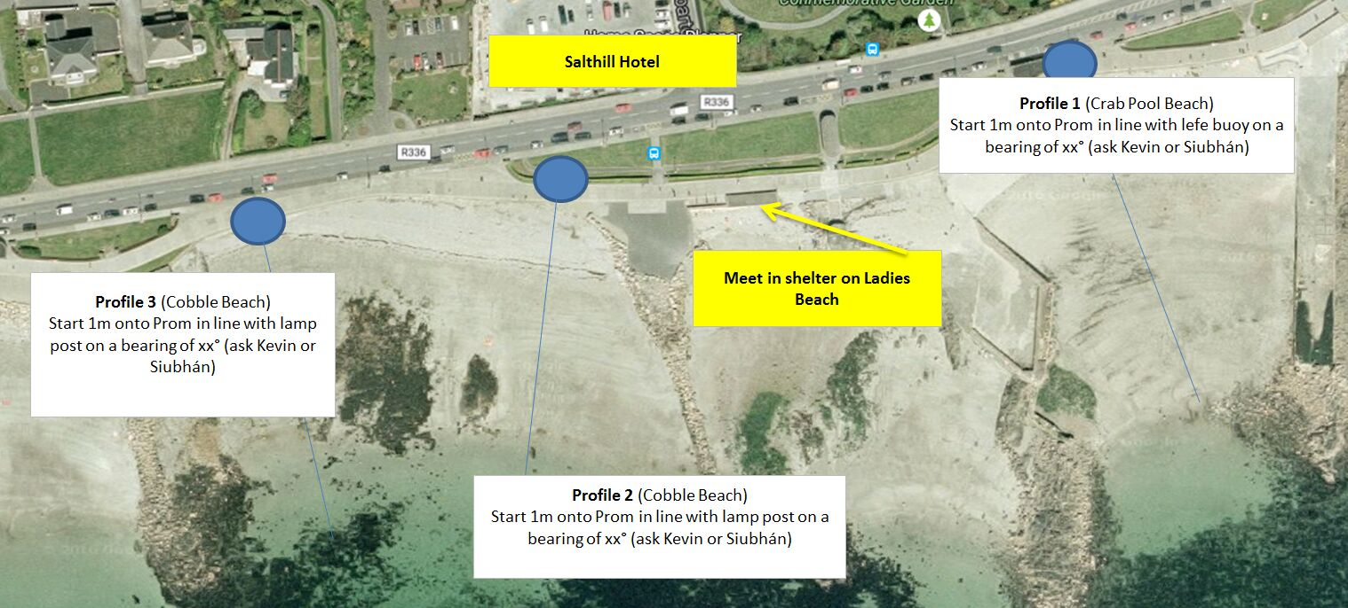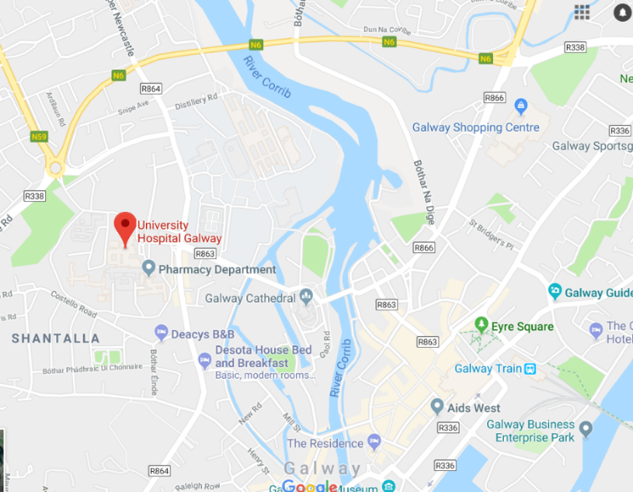
Karen
Karen
Karen
Karen
:

