**Retired staff parking permit request.**

If a retired member of staff is continuing to provide work or contribution to the work of the University, then a Temporary Retirement Permit can be applied for using this form.

**Instructions**

* This form must be completed by the retired member of staff and then authorised by the relevant Dean or Head of School or UMT member (in the case of Support Staff)
* Email completed form to [securityo@universityofgalway.ie](mailto:securityo@universityofgalway.ie)
* Visit [www.nuig.apcoa.ie](http://www.nuig.apcoa.ie) and create a new account (Choose ‘Create Account’ in top right corner, and continue using your own personal email address. Insert required details including car make and registration.
* Click on Apply for Permits’ and Apply for a Non-University Staff Permit and register
* Your completed application will be reviewed in due course and if approved, your Permit application will be approved, you will get a notification by email to complete the payment.

**Please Note:**

* If you are retiring during an academic year, and you have already purchased a Staff Permit – this will continue to be valid until the end of the academic year (31st August)
* Permits are only valid for a maximum of one year. If your contribution continues for into a new academic year, you will need to re-apply for another permit, repeating the process above.

Please provide hereunder brief details of the **contribution** that you are making to the work of the University. Please also provide an indication of the **time commitment** involved in your contribution.

**APPLICANT NAME** (print in Capitals) **STAFF ID NO**.

**CONTACT NUMBER:**

**SIGNATURE OF APPLICANT DATE:**

**ENDORSEMENT**

Retired academic staff should ensure that this form is endorsed with the **personal signature** of the relevant **Dean or Head of school.** Retired support staff should ensure that this form is endorsed with the **personal signature** of the relevant **UMT member.**

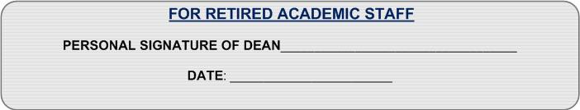

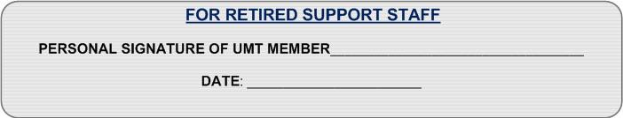

Please return this form, when completed, to [securityo@universityofgalway.ie](mailto:securityo@universityofgalway.ie) **, University of Galway**. Please note that rubber stamps or other facsimile signatures are not acceptable for these purposes.