University Skills Passport (USP) – Curricular Badge Set up Form
Thank you for engaging with the USP - University Skills Passport. This form will determine the eligibility of your activity for inclusion on the USP - University Skills Passport. You are required to fill out one form for each badge that you would like to award. It will capture the basic data required to set up your activity on the USP platform and to set up the credentials that you choose to award your students on completion of your activity (Digital Badge / USP - University Skills Passport).
Should you wish to change the setup outside of the annual review process please email USP@universityofgalway.ie.
- Module code:

- Title:
Enter a short, clear title (maximum 50 characters) for this module. This title will appear on the badge certificate and on the University Skills Passport. It does not have to match the full module title.

- Hosting Unit: Please specify the College, School, or Discipline(s) associated with this module.

- Module Owner contact Details:
Name:
Email:
Phone:

- “Contact Us” Email address
(Email Correspondence from students enquiring about your badge will be directed to this address)
“Contact us” Email:

- Target Cohort – Please X relevant cohorts
Undergraduate
Postgraduate
All

- Duration of the Activity:
Duration that the activity typically spans (e.g., X weeks, Semester 1, Semester 2, yearlong)

- Time Commitment in Hours (Min)
What is the usual time commitment associated with this badge? If a range of hours is likely, please indicate what the minimum time commitment is?

- Expiry
Do credentials associated with your activity have an expiry? If yes, please specify details:
(For example duration of an accredited certification that is valid for a period after completion of exam)

- Badge Visual Identity:
Digital badges for Academic activity follow a standard design as provided below. The image at the centre is standard for all curricular badges. Specify the badge logo PRIMARY TEXT, this will be capitalised (Maximum 26 characters) Note: This may differ from the module name given that the space is limited. Specify the badge logo SECONDARY TEXT, this will be capitalised (Maximum 34 characters). E.g., it can be your College, Discipline, School or other as space allows. Note: Some variability is possible given the interplay between both texts
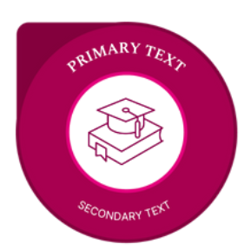
PRIMARY TEXT, this will be capitalised (Maximum 26 characters).
SECONDARY TEXT, this will be capitalised (Maximum 34 characters).

- Badge Description
This description will be recorded on the metadata associated with the digital badge. This should explain to a student and an external partner what the badge is about and what a student has completed in order to achieve the badge. Recommended text length: Description AND criteria 150 words – Maximum length 200 words.

- Criteria to earn this Digital Badge
Please list a brief formal description of how the student earns this badge. This description will be recorded on the metadata associated with the digital badge. This should explain what a student has completed in order to achieve the badge (i.e., badge criteria: Attendance, Written reflection, presentation etc,)
To earn this badge the student must:

- Verification
Describe the validation process used to verify that the student has satisfactorily completed this activity? (Attendance log, Formal assessment, Grade downloaded from canvas, other)

- (a) Skills and Dispositions
  - Please select up to five skills and/or dispositions in the Designing Futures Framework that the student will develop upon completion of this activity.
  - For each skill stated please, identify at least one specific example of how the student will develop this skill/disposition. The example should clearly outline what the student did in this context to develop the skill highlighted.
  - The example should be short and concise, 1 – 4 sentences long and phrased in the past tense.
  - Please find the Skills Framework and associated examples available for your reference here.

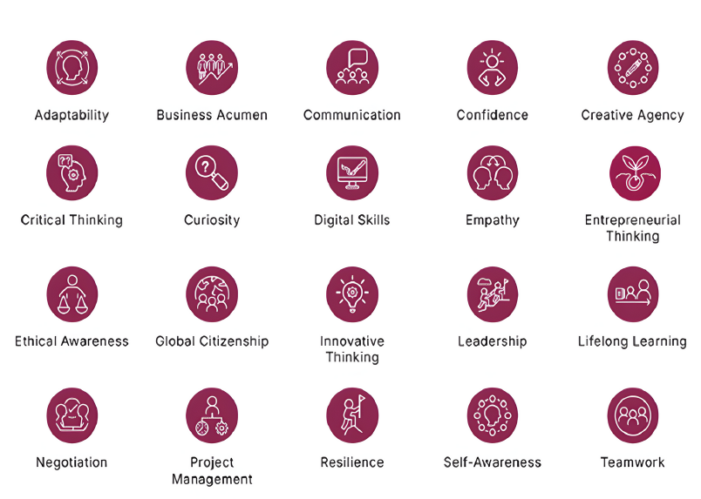

Note: In the skills/disposition description area below, please describe how the student developed their skill /disposition by undertaking this activity.
Skill / Disposition | Skill/Disposition Description: Give specific examples of how this skill/disposition was acquired while undertaking this activity:
1.
2.
3.
4.
5.

Section 14 (b)
OPTIONAL NOT REQUIRED: Domain Specific competencies / Technical Competencies
If you would like to highlight domain specific competencies / technical competencies that are outside of the skills framework, please list them here.
- You should list the name of the competency and a short description (Max 1 line) only if required.
- The text should be short and concise and phrased in the past tense.
- Note: If you choose to list competencies below you should only capture 4 skills in the skills section above
Domain Specific Competency / Technical Competency list
1.
2.
3.
4.
5.

