University Skills Passport (USP) Co/Extra-Curricular Badge Setup Form
Thank you for engaging with the USP - University Skills Passport. This form will determine the eligibility of your activity for inclusion on the USP - University Skills Passport. You are required to fill out one form for each badge that you would like to award. It will capture the basic data required to set up your activity on the USP platform and to set up the credentials that you choose to award your students on completion of your activity (Digital Badge / USP - University Skills Passport).
Should you wish to change the setup outside of the annual review process please email USP@universityofgalway.ie.
- Title of activity:
Enter a short, clear title (maximum 50 characters) for the activity. This title will appear on the badge certificate and on the University Skills Passport Activities Hub

- Hosting Department
Please specify the University department that currently has responsibility for this activity (e.g., Professional Services Department/College/School/Discipline/Student’s Union/Other)

- Activity Owner Contact Details:
Name:
Email:
Phone:

- “Contact Us” Email address:
(Email Correspondence from students enquiring about your badge will be directed to this address)
“Contact us” Email:

- Activity Webpage
Please include a URL link to your activity’s web page (If relevant):

- Short Description of Activity to appear on the University Skills Passport Activity Hub.
Please provide a brief description of your activity; this description will appear on the USP -University Skills Passport activities webpage. Recommended text length: 150 words. A user may be an external user browsing activities OR an existing student exploring activities / badges; the tone of the text should be engaging, open and welcoming. It should describe to someone who knows nothing about the activity, what the activity is about in an informal way. It should conclude with a call to action e.g. Artsoc: Join us to unlock your artistic abilities!

- Target Cohort – Please X relevant cohorts

Undergraduate | Yes/No
Postgraduate | Yes/No
All | Yes/No

- Location of this activity (e.g. University of Galway, Shannon College, Online, Burren College)

- Is participation in the activity Paid or Unpaid?

- Duration of the Activity:
Duration that the activity typically spans in weeks and how frequently you typically recognise completion of this activity (e.g., once per semester, per academic year, ad hoc)

- Time Commitment in Hours (Min)
What is the usual time commitment associated with this badge? If a range of hours is likely, please indicate what the minimum time commitment is?

- Student Enrolment Practise
How are students currently enrolled on your activity? (Opt-in, Auto-enrol, elected, other)

- Tracking and Administration Tools
What system(s) do you use currently to administer your award? (Yourspace, Excel, Canvas, Other)

- Expiry
Do credentials associated with your activity have an expiry? Please specify Yes / No. If yes, please specify details: (For example duration of an accredited certification that is valid for a period after completion of exam like health and safety certification)

- Badge Visual Identity:
Each badge is comprised of a visual identity at the centre of the badge and two text elements – the Primary and Secondary text. Please include any images of your activity's current visual identity OR existing digital badge (If Relevant). Please attach high quality image of png / svg, 200 x 200 pxls, file to email if available. Please specify the Primary text and Secondary text for the badge. Approximate primary text length: 26 characters, Approximate Secondary Text length: 34 characters. Note: Some variability is possible given the interplay between both texts
We can work with you to generate an image from a university-approved template.
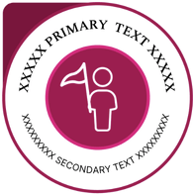
PRIMARY TEXT, this will be capitalised (Maximum 26 characters).

SECONDARY TEXT, this will be capitalised (Maximum 34 characters).

- Image for your Activity for the Website
We will need an image 696x312px that will represent your activity on the USP website. Please attach high quality image of png / jpeg file to email. This image will appear on the activity tile as represented in the example below.
The image will be applied at the top of your activity tile on the portal. See example below.


- Badge Description
Please provide a brief description of your badge. This description will be recorded on the metadata associated with the digital badge. This should explain to a student and an external partner what the badge is about and what a student has completed in order to achieve the badge. Recommended text length: Description AND criteria 150 words – Maximum length 200 words.

- Criteria to earn this DIGITAL BADGE
Please list a brief formal description of how the student earns this badge. This description will be recorded on the metadata associated with the digital badge. This should explain what a student has completed in order to achieve the badge (i.e., badge criteria: Attendance, Written reflection, presentation etc,)
To earn this badge the student must:

- Verification
Describe the validation process used to verify that this activity has been satisfactorily completed by the student?

- Skills and Dispositions
- Please select up to five skills and/or dispositions in the Designing Futures Framework that the student will develop upon completion of this activity.
- For each skill stated please, identify at least one specific example of how the student will develop this skill/disposition. The example should clearly outline what the student did in this context to develop the skill highlighted.
- The example should be short and concise, 1 – 4 sentences long and phrased in the past tense.
- Please find the Skills Framework and associated examples available for your reference here.

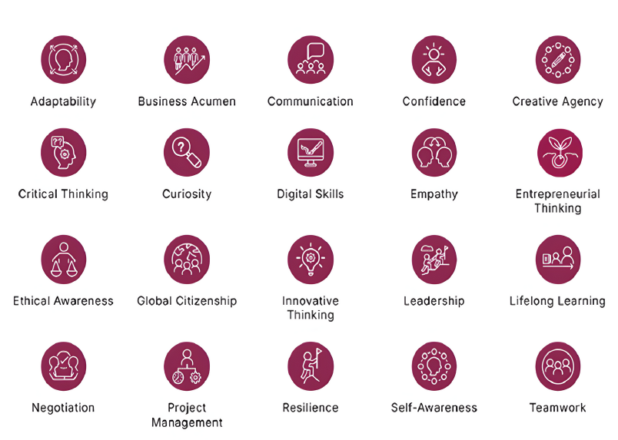

Note: In the skills/disposition description area below, please describe how the student developed their skill /disposition by undertaking this activity.
Skill / Disposition | Skill/Disposition Description: Give specific examples of how this skill/disposition was developed while undertaking this activity:
1.
2.
3.
4.
5.

