National Workplace Wellbeing Events: April 2025.The theme of our events this year is the importance of Connection
Tuesday April 29 | Wednesday April 30  National Workplace Wellbeing Day . | Thursday May 1st
Morning Connect:  8:10am – 8:40am. Kingfisher Club. Join Jacqui Fernades for 30 minutes of ME time. Comfortable clothing required. After class refreshments for those who participate. Register Here | Mindful Eating Clinics with John Core, Sodexo’s Culinary Nutrition Lead. These short 20-minute, focused sessions are designed to help participants: reflect on their current eating habits, learn practical strategies to improve energy, mood, and performance through nutrition. Sessions 8.15 to 8.45: 9.00am to 9.30: 9.45 -10.15am. Venue: HBB G001.  Open session: audience led 2.30 – 3pm: Venue HBB G019. Book your place Here  Interactive Healthy Street Food demonstration with recipes. These dishes combine bold global flavours with nutritious whole food ingredients and will be accompanied by QR codes linking to the full recipe collection. No booking required.  11.30 am – 2pm Venue: An Bhialann. | Morning Connect  8.10- 8.40am: HBB G001  A seated active talk with tips and trips of how to stretch and move at your desk. Take away information will be provided. After class refreshments for participants.  Please register: Here
Bank of Ireland Financial Wellbeing Talk Planning for the future.
Savings Shorter, Medium longer:
11.30 am to 12.00pm: Venue HBB: G019. Click on the image of BOI below, open the link and register.
Register: Here for catering purposes.
  - appointments available on campus during the day.
www.BankofIreland.com/BankatWork

Below the Belt (Film)
The story of Endometriosis.
In partnership with the Student Union. Venue: G001.
2.30 – 4pm.
Please register Here for catering purposes.

Inaugural Book Club meeting:
Our first book club choice is Una Mannion's Tell Me What I Am, which won the Crime Writer's Association Gold Dagger in 2024. 1pm Venue: G011 in the Hardiman Building. Please register. Here
Sign up here to join the mailing list for the book club. Here

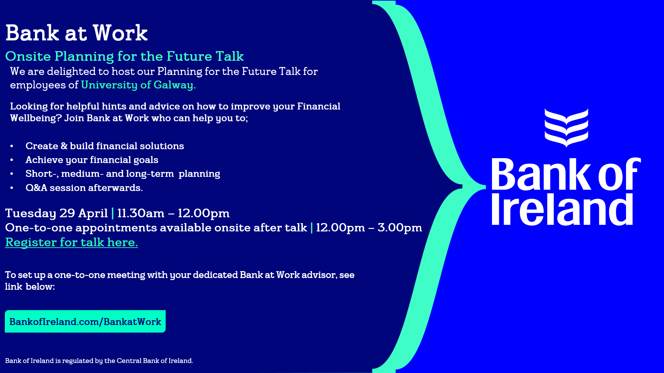

Wellbeing Dates for Your Diary:

May 15^{th Hello} How Are you campaign. A Connect Café will provide opportunities to chat with colleagues and continue the connections from National Workplace Wellbeing Day.

June 10th Men’s Health Week, we will be providing opportunities for all staff to participate in information and activity sessions. Men’s Health

Commencing September 2025, we will be offering a monthly talk on a pillar of Wellbeing.
January 2026: Be Active -
this module continues to be developed is currently being scoped out with additions to the programme to include nutritional clinics and
15-minute 1-1 wellness personalized information sessions.
If you have any suggestions ideas on talks or topics or how to meet colleagues on a more regular basis.
Please email wellness@universityofgalway.ie.

